Lecture 8
Spreadsheet applications

Spreadsheet applications grow one day after the other. Engineers use these applications for many reasons, but in our context we will focus on the use of spreadsheet applications for engineering economy analysis and modeling.
Microsoft Office Excel® is one the most commonly used software for spreadsheet purposes. This software has a lot of financial and mathematical intrinsic functions, which were defined during previous lectures.
Following are examples for the use of Excel spreadsheets to solve cash flow problems.
Links to excel files are available in appendix A for more details.

Example 8.1:

A new software will be injected in an existing company, It is expected that the software will increase annual revenue over that the current software by 200000 m.u. for each of the next 2 years, and by 300000 m.u. for each of years 3 and 4. The planning horizon is only 4 years.
Develop spreadsheet to answer the following questions:
(a) Determine the equivalent future value in year 4 of the increased cash flows, using an 8 % interest rate of return for both simple and compound interest
(b) Rework part (a) if the flow estimates in year 3 and 4 increase from 300000 m.u. to 600000 m.u.
(c) Consider the effects of 4% inflation in the analysis, hence the rate of return from will be reduced from 8% to 3.85% per year

Solution:
The spreadsheet solution for part (a)

Figure 8.1 Spreadsheet solution for example 8.1(a)

Spreadsheet solution for part (b)

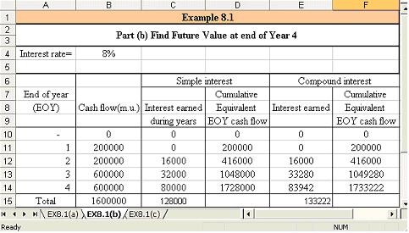
Figure 8.2 Spreadsheet solution for example 8.1(b)

The Spreadsheet solution for example 8.1(c)

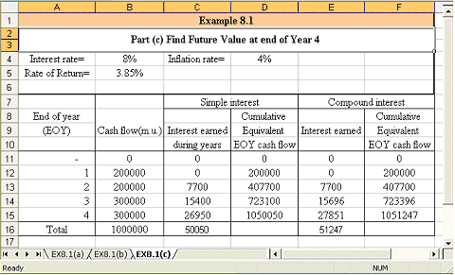
Figure 8.3 Spreadsheet solution for example 8.1(c)

Tip 1:
When working with Excel as a spreadsheet it is possible to display all the entries and functions on the screen by clicking “CTRL”+ “~” which might be in the upper left of the keyboard.

Example 8.2:

A person buys a piece of property for 5000 m.u. downpayment and deferred annual payments of 500 m.u. per year for 6 years starting 3 years from now. How much would he pay if he decides to pay the entire price immediately? The interest rate is 8 %.

Solution:

Figure8.4 Cash flow for example 8.2

P=5000+500 (P/A, 8, 6) (P/F, 8, 2)
=5000+500((1.086-1)/ (0.08(1.08)6))*(1/1.082) = 6981.69 m.u.

The spreadsheet solution for this example could be obtained as shown in figure 8.5 using either of the engineering economy factors or the intrinsic PV function.

Figure 8.5 Spreadsheet solution for example 8.2

Example 8.3:

A principal P is deposited now in a bank with an interest rate of 4.5%. The principal is required to be completely recovered in the form of equal annual withdrawal of 200 m.u. per year for the first 5 years starting one year after deposit; then a different annual withdrawal of 300 m.u./year for the following 3 years. Determine the value of P.

Figure 8.6 Spreadsheet solution for example 8.3

Also another simple Excel solution using the NPV intrinsic function can be obtained as shown in figure 8.7.
Figure 8.7 Another spreadsheet solution for example 8.3

Example 8.4:

For a nominal interest rate of 15% calculate the effective interest rate if the interest is compounded:
- Biannually,
- Quarterly,
- Monthly
- Continuously( m= ∞)

Solution:

Figure 8.8 Spreadsheet solution for example 8.4

Example 8.5:

A company will make seven consecutive annual investments starting 3 years from now. The first investment is 100000 m.u. and the investments decrease at an annual rate of 10 %. What will be the compound amount 14 years from now if the interest rate is 12 %? Determine the single investment that should be made now in order to yield the same amount 14 years ahead.
Find the equivalent uniform series of 14 year-end investments which would result in the same amount at the same time. (NB: This example is same as that of example 6.7; however, two spreadsheet solutions will be introduced).

Solution:

Spreadsheet solutions are presented in figures 9, 10. In the former PV, FV, and PMT functions are used, but in figure 10 NPV function is introduced in order to facilitate the model.
Figure 8.9 Spreadsheet solution for example 8.5

Figure 8.10 Another spreadsheet solution
Example 8.6:

Table 8.1: represents the cash flow of the two Plans A & B, select between the two plans based on annual cash flow analysis. (Spreadsheet solution for example 7.6.)

Table 8.1: cash flow parameters for example 8.6:
 | Plan A |  | Plan B
 | Machine 1 | Machine 2 | Plan B
First cost, m.u. | 90,000 | 28,000 | 175,000
Annual operating cost, m.u./year | 6,000 | 300 | 2,500
Salvage value, m.u. | 10,000 | 2,000 | 10,000
Life, years | 8 | 12 | 24

Solution:

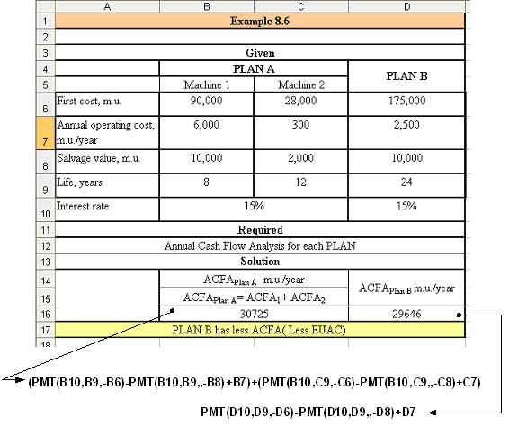
Figure 8.11 Spreadsheet solution for example 8.6

Example 8.7:
Determine the annual cash flow analysis for each Plan based on 8% interest rate for the cash flow shown in table 8.2. Plans A, B, and C has a ten-year life and a scrap value equal to 10% of its original cost. Also find the capitalized profit for each plan.

Table 8.2: Cash flow of Plans A, B and C for example 8.7
 | Plan A | Plan B | Plan C
Installed cost of equipment m.u. | 15000 | 25000 | 33000
Material and labor saving per year m.u./year | 14000 | 9000 | 14000
Annual operating expenses m.u./year | 8000 | 6000 | 6000
Scrap Value m.u. | 1500 | 2500 | 3300

Solution:

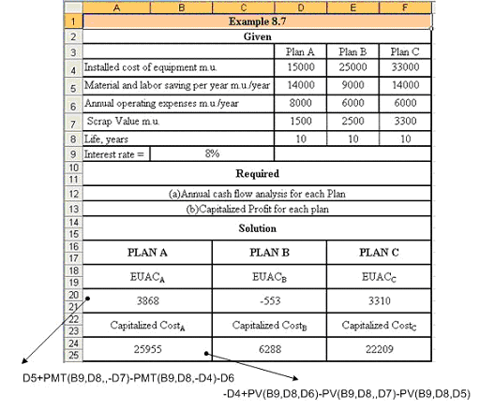
Figure 8.12 Spreadsheet solution for example 8.7

Note:
- The annual cash flow in such case is the annual income or annual inflow amount, therefore the plan which has the maximum annual cash flow is the best.
- The capitalized profit is the present equivalent amount for the profit gained from each plan through its life.
Appendix A
Links to Spreadsheets,
Example | link
Example 8.1 | EX8.1.xls
Example 8.2 | EX 8.2.xls
Example 8.3 | EX 8.3.xls
Example 8.4 | EX 8.4.xls
Example 8.5 | EX 8.5.xls
Example 8.6 | EX 8.6.xls
Example 8.7 | EX 8.7.xls

