Lecture 6

NONUNIFORM SERIES

In some cash flow situations, series of end-of-period payments are not equal. These unequal payments may constitute a non-uniform series. Two types of gradually-changing non-uniform series can be analyzed mathematically in order to develop standard solutions for these situations. These two types are: arithmetic progression series and geometric progression series.

6.1 Arithmetic-Progression Series:

The payment changes (increases or decreases) by a fixed amount from one period to the next. The cash-flow diagram of such a series is illustrated in fig. 6.1.

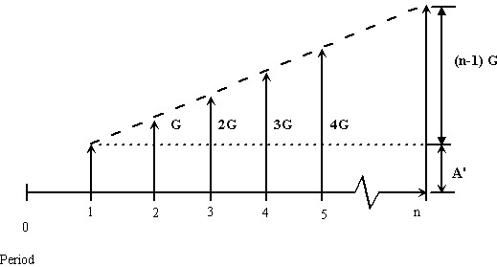
Figure 6.1 Cash flow showing an arithmetic progression series

The first payment A' is called the "Base Payment" and the arithmetic change between any two successive payments G is called the “Gradient”. In general, the gradient may be positive or negative. The series shown in figure is known as the typical "Uniform Gradient Series". The payment at the end of period number j is.

In order to work out the compound amount, the present worth or the equivalent uniform series, the series in the figure may be split into two parts. These are the base-payment uniform series shown in figure 6.2 a and the arithmetic progression starting at the end of the second period, as shown in figure 6.2 b , which is called "Conventional Gradient".

Figure 6.2 a The uniform-series part of the arithmetic progression

Figure 6.2 b The gradient part of the arithmetic series

6.1.1 Uniform-Gradient Compound Amount

The future compound amount F will be considered as the sum of two components
(6.1)

Where F' and F* are the compound amounts of the base payment uniform series and the conventional gradient respectively. Thus,
(6.2)
(6.3)

The amount F*can be obtained as the sum of the compound amounts of the succession of different single payments shown in fig.6.2 b:
(6.4)
Multiplying by
(6.5)

Subtracting the above two equations
(6.6)

The terms between brackets, excluding the last one, are a geometric progression with a first term 1 and a common ratio
(6.7)

The term multiplied by G, in eqn.(6.7) , may be regarded as a conversion factor used to find F* when G is known , i.e. a conventional-gradient compound-amount factor. Thus, it may be put in the standard factor notation
(6.8)

The total compound amount of the uniform gradient series may be obtained, by substituting from equations.(6.3) and (6.7)into equation.(6.1), in the form
(6.9)
Example 6.1:

A company expects to realize revenue of m.u. 100,000 during the first year starting now from the sale of a new product. Sales are expected to decrease gradually with competition, following a uniform gradient, to a level of m.u. 47,500 during the eighth year from now. Draw the cash-flow diagram following the end-of -period convention. If the revenue is invested at a rate of 10 % what will be the compound amount eight years from now?

Solution:

G = - ((10⁵-47500)/7) = - 7500 m.u.
A' = 10⁵ m.u.
n=8 & i=10%
F=F'+F*= A'(F/A, 10, 8) + G(F/G, 10, 8)
=10⁵((1.1⁸-1)/0.1) – 7500/0.1(((1.1⁸-1)/0.1)-8)
= 885897.2 m.u.

Figure 6.3 Cash flow diagram for example 6.1

6.1.2 Uniform Gradient Present Worth

The present worth of the uniform gradient series can be found as the sum

(6.10)

Where P' is the present worth of the base payment uniform series and P* is the present worth of the conventional gradient. Accordingly,
(6.11)

and
(6.12)

From equation (6.7),
(6.13)

Based on equation (6.13), a conventional gradient present worth factor may be defined in the form
(6.14)

The total present worth of the uniform gradient series can be obtained, by substituting from equations (6.11) and (6.13) into equation (6.10), in the form
(6.15)
Example 6.2:
A textile mill has just purchased a lift truck that has a useful life of 5 years. The engineer estimates that the maintenance costs for the truck during the first year will be m.u.1,000. Maintenance costs are expected to increase as the truck ages at a rate of m.u.250 per year over the remaining life. Assume that the maintenance costs occur at the end of each year. The firm wants to set up a maintenance account that earns 12% annual interest. All future maintenance expenses will be paid out of this account. How much should the firm deposit in the account now?

Solution:

Given: A₁ = m.u.1,000, G = m.u. 250, i = 12% per year, and n = 5 years
Find: P
This is equivalent to asking what the equivalent present worth for this maintenance expenditure if 12% interest is used. The cash flow may be broken into its two components as shown in Figure 6.4

.
Figure 6.4 Cash flow diagram for example 6.2

The first component is an equal-payment series (A₁), and the second is linear gradient series (G).
P = P₁ + P₂
P = A₁(P/A, 12%, 5) + G(P/G, 12%, 5
= 1000 (1 – 1.12⁻⁵) / 0.12 + 250 [(1.12⁵-1) / 0.12-5] / (0.12 × 1.12⁵)
= 1,000(3.6048) + 250(6.397)
= 5,204 m.u.

Note that the value of n in the gradient factor is 5, not 4; because, by definition of the series, the first gradient value begins at period 2.
Comment: As a check, we can compute the present worth of the cash flow by using the (P/F, 12%, n) factors; as shown in the next table.

The slight difference is caused by a rounding error.
Period [n] | Cash Flow | (P/F, 12% , n) | Present Worth
1 | m.u. 1000 | 0,8929 | m.u.892.90
2 | 1250 | 0,7972 | 996.50
3 | 1500 | 0.7118 | 1,067.7
4 | 1750 | 0.6355 | 1,112.13
5 | 2000 | 0.5674 | 1,134.80
Total |  |  | m.u.5204.03

6.1.3 Uniform Series Equivalent to a Uniform Gradient

The uniform gradient may be replaced by an equivalent uniform series A which yields the same compound amount (and has the same present worth). The value of A can be obtained as the sum
A = A' + A* (6.16)

Where A* is a uniform series equivalent to the conventional gradient. Thus,

Substituting for F* from equation (6.7)
(6.17)

Accordingly, a conventional gradient uniform series factor may evolve in the form
(6.18)

The total uniform series equivalent to the uniform gradient series can be found, from equations (6.16) and (6.17), as

(6.19)

Example 6.3:

A company is planning to invest at 7% as shown in figure by the increasing gradient, then to withdraw according to the shown pattern. Find the present worth and the equivalent uniform series for the whole plan.

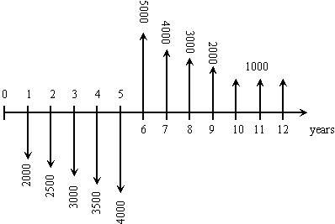
Figure 6.5 Cash flow for example 6.3

Solution:

P_{I} = present worth of investment =

P_{I}=

= 2000

= present worth of withdrawal =

=

is actually a negative cash flow and is a positive cash flow.
The resultant present worth P is
P = - = 10084.8 – 12023.4 = - 1938.6 m.u.

The equivalent uniform series A is found from

Example 6.4:

A firm receives a series of eight loans from the government following the uniform gradient shown in figure. The loan will be repaid in a single payment 14 years from now. Determine the amount to be paid if the interest rate is 12 %. What is the present value of this borrowing plan?

Solution:

G = 50000 m.u.
A' = 1.5 × 10⁵ m.u.
P = P' + P* = 1.5×10⁵ ((1.12⁸-1)/ (0.12×1.12⁸)) +
((0.5×10⁵/0.12*1.12⁸) × (((1.12⁸-1)/0.12)-8)
P = 14.687×10⁵ m.u.
F =14.687×10⁵ (F/P, 12, 14) =14.687×10⁵ (1.12)¹⁴
= 71.78×10⁵ m.u.

Figure 6.6 Cash flow diagram for example 6.4

6.2 Geometric Progression Series

This is a non-uniform series which grows or declines at a constant percentage rate per period (rather than a fixed amount as the case for a uniform gradient). Figure 6.7 illustrates an escalating series and declining series both having the same numerical rate of 10%. The first payments is denoted by A' . The percentage rate of change has the symbol E and may be called an "Escalation rate" or a "Declination rate" depending on whether its value is positive or negative respectively.

Figure 6.7 Cash flow diagrams representing the geometric series

The general cash-flow model of a geometric-progression series is shown in fig.6.8. The payment at the end of any period, number j, is. The model in this figure helps in deriving the expressions for the compound amount, the present worth and the equivalent uniform series of a geometric progression series.

Figure 6.8 Cash flow model of the geometric series

6.2.1 Compound Amount of a Geometric Progression

Figure 6.9 The future compounded value for a geometric series increasing with E %

The compound amount of the series can be found by summing up the compound amounts of individual payments each treated as a single payment.
The quantity between brackets comprises n terms of a geometric progression having a first term (1+i)^{n–1} and a common ratio (1+E)/ (1+i). Accordingly,
(6.20)

In the special case of E=i , eqn.(6.20) has to be modified by applying L'Hopital's rule for indeterminate quantities. The equation will reduce to
(6.21)

6.2.2 Present Worth of a Geometric Progression

Figure 6.10 The present worth for a geometric series increasing with E %

The present worth can be found from
From eqn.(6.20)
(6.22)

And from equation (6.21)

(6.23)

6.2.3 Uniform Series Equivalent to a Geometric Progression

Figure 6.11 Equivalent uniform series for a geometric series
The equivalent uniform series can be obtained as
From equation (6.20)
(6.24)

And from equation (6.22)
(6.25)

Example 6.5:

Calculate the equivalent present cost of 35000 m.u. expenditure now and 7000 m.u. / year for 5 years beginning 1 year from now with increases of 12% per year thereafter for the next 7 years. The interest rate is 15%.

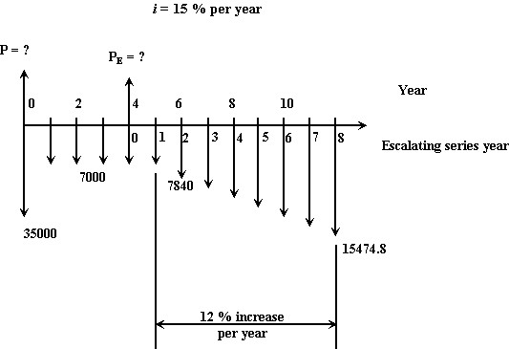
Figure 6.12 Cash flow diagram for example 6.5

Solution:

The escalating series can be converted to a single payment P_{E} at the zero time of the escalating-series scale. From equation (6.22),
= 35000 + 19984.849 + 25428.206 = 80413.055 m.u.

Example 6.6:

A succession of eight deposits follows a geometric-progression series which has a first payment of 30,000 m.u. The payment at the end of the third period is 38,988 m.u. Find the compound amount at the time of the eighth deposit and the present worth if the interest rate is 14 % per period.

Solution:

Figure 6.13 Cash flow diagram for example 6.6

A'= 30,000 m.u.
38988= (1+E)² A' = 30000(1+E)²
1+E = 1.14
E = 14%
E = i
F = A' n (1 + E)^{n-1}
F = 30000*8(1.14)⁷ = 600.545 × 10³ m.u.
P = A' n / (1 + E)
P =30000(8/1.14) = 210.526× 10³ m.u.

Example 6.7:

A company will make seven consecutive annual investments starting 3 years from now. The first investment is 100,000 m.u. and the investments decrease at an annual rate of 10 %. What will be the compound amount 14 years from now if the interest rate is 12 %? Determine the single investment that should be made now in order to yield the same amount 14 years ahead.
Find the equivalent uniform series of 14 year-end investments which would result in the same amount at the same time.

Solution:

E ≠ i
F = A' [((1 + E)^{n} – (1 + i)^{n})/(E – i)] × (F/P, 12%, 5)
F=10⁵[((1-0.1)⁷-(1.12)⁷)/(-0.1-0.12)](1.12⁵) = 13.8775 × 10⁵ m.u.
P =13.8775 × 10⁵ (P/F, 12, 14) = 13.8775 × 10⁵ / 1.12¹⁴ = 2.84× 10⁵ m.u.
A = P (A/P, i, n)
A= 2.84× 10⁵ (0.12(1.12)¹⁴/ (1.12¹⁴-1)) = 4.285 ×10⁴ m.u.

Figure 6.14 Cash flow diagram for example 6.7

Example 6.8:
A company owning an area of land decided to sell the mineral rights on its property to a mining company. The objective was to obtain long-term income in addition to two lump sums to finance two future projects. The long-term annual income starts after one year at 100,000 m.u. / year and increases by 15 % each year and continues for 20 payments. The required capitals and the scheduled times for the two projects are 5 and 10 million m.u. eight and twelve years from now respectively. If the mining company wants to pay off its lease immediately how much would it have to pay now if the interest rate is 6 %?

Solution:

P = 5×10⁶(P/F, 6%, 8) + 10×10⁶(P/F, 6%, 12)
+10⁵ [((1 + E)²⁰ – (1 + i)²⁰) / (E – i )] / (1 + i)²⁰
P = 5×10⁶(1/1.06⁸)+10⁷(1/1.06¹²)+10⁵(1/1.06²⁰)((1.15²⁰)-(1.06²⁰))/(0.15-0.06)
= 12.666×10⁶ m.u.
Figure 6.15 Cash flow diagram for example 6.8

